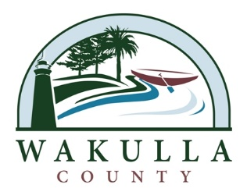

NOTICE OF PUBLIC MEETING

The Wakulla County Tourist Development Council will hold a Public Meeting on Thursday November 14, 2019 at 9:00 a.m. in the Wakulla County Board of County Commissioners Administration Conference Room, 3093 Crawfordville Highway, Crawfordville, FL 32327
(850) 926-0919 ext. 713

Purpose of Meeting:

To Discuss General Business of the

Tourist Development Council

It is the mission of the Wakulla County Tourist Development Council to promote and facilitate travel to and within Wakulla County for the benefit of its economy, residents, and travel/tourism industry. The TDC's vision is to be recognized as the county's official marketing and management organization to responsibly promote and protect the natural resources, recreational opportunities, and rich heritage of Wakulla County in coordination and collaboration with the Board of County Commissioners, Economic Development Council, and tourism industry partners. If a person decides to appeal any decision made by the board, agency, or commission with respect to any matter considered at such meeting or hearing, he or she will need a record of the proceedings, and that, for such purpose, he or she may need to ensure that a verbatim record of the proceedings is made, which record includes the testimony and evidence upon which the appeal is to be based
Persons with a disability needing a special accommodation should contact the Wakulla County Board of County Commissioners Administration Office at least two (2) days prior to the meeting at (850) 926-0919; Hearing & Voice Impaired at 1-800-955-8771; or email at ADARequest@mywakulla.com

